MISC FOLDER FOR PREP CHARGES.

**Please ntoe, this logic may only be available with Version 10 due to the new data base files and fields that were added.**

**Adding pre-press charges to a order so that it gets billed to the customer along with the cartons?**

**The cost estimate folder called PREP/ROUTE has option to add many prep charges.   
The charges must first be added to the E-B-7 PREP File. When adding to the estimate, add this as a “S”eparate Charge which will be billed outside the cost per M. When adding an Order, the prep charges will be move to the MISC screen of the order.   
  
Alternatively, you can MANUALLY add to the order on the MISC folder. You can click INVOICE button and invoice immediately. Prep charges are automatically invoiced with first invoice via BOL.**

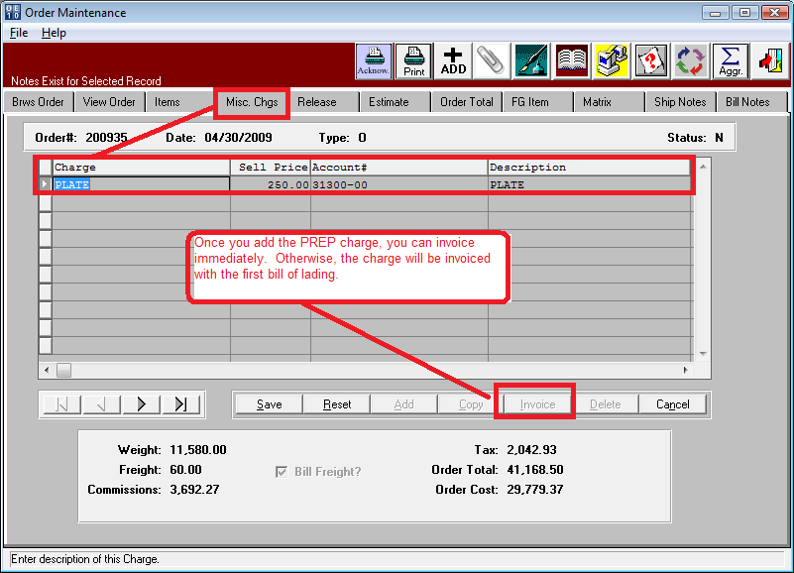

**How do I enter and print a purchase order for a cutting die to send to our vendor?**

**Purchase orders for prep charges should be added to the E-B-7 PREP file. The prep code is used for cost estimating. However, a raw material code must be added (May be same exact code) to the raw goods file. For example, the prep charge called PLATE may be both a prep code and a raw materials code. You can create raw materials as MISC material, but would be better as exact material type via N-Z-3 file. Cutting Dies are Material Type = 8, Plate = 7, etc.**

**Note the RM item code matches the Prep Code, but this is not mandatory.**

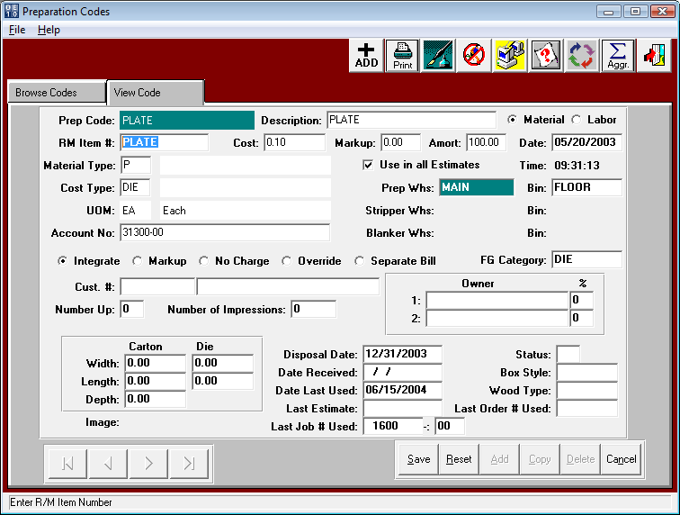

**How do I enter and print a purchase order for a cutting die to send to our vendor?**

**Raw Materials must be added for each pre-press code. The material type may be defined as “M” for miscellaneous material. However more The new codes will be used to automatically update the schedule board. If the numbers are missing from the N-Z-3 file, you must manually add them so that you can select via Raw Materials File. Version 10 has many new material codes such as 7 for cutting dies, 8 for plates, X for Rotary Die, Y for Flat Die, etc. The new codes will be used to automatically update the schedule board.**

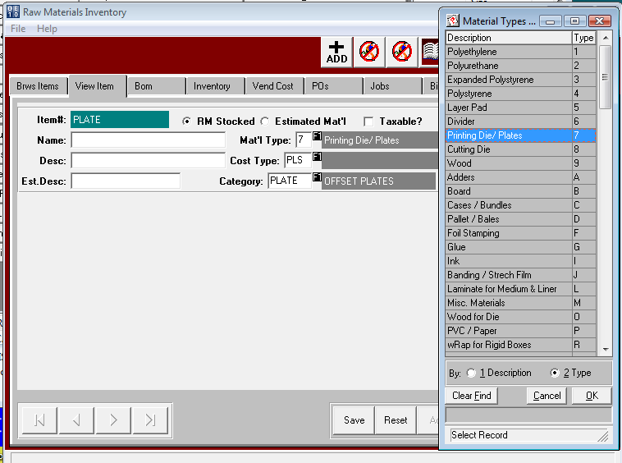**.**

**How to add die charges, linked with the PO, to a factory order and updated customer cost and actual cost.**

**Steps 1 and 2 Above msut be added. The estimate must have the prep charge in order to print on the job ticket. The job card must have the logic to print the prep codes.**

**Adding a purchase order for the raw material, with the JOB number will automatically add the ORDER# to the bottom of the PO Line. If you add the purchase order without a job number, then you must manually add the order number. Once the order number is on the purchase order to the vendor, the cost on the PO will then transfer back to the MISC folder of the Order, thus linking the Sell Price and Cost to the Prep Charge.**

